***Intermediate Algebra (A) Name _____________________________***

***1.3E Review Class period 1 2 3 4 5***

1. One cup of Doggie Dinner contains 20 grams of protein and 40 grams of carbohydrates. One cup of Puppy Power contains 30 grams of protein and 20 grams of carbohydrates. Susan's vetrenarian puts her dog on a special diet that contains at least 200 grams of protein and 180 grams of carbohydrates per day. Let D stand for the number of cups of Doggie Dinner and P stand for the number of cups of Puppy Power. If Doggie Dinner costs 16 cents per cup and Puppy Power costs 20 cents per cup, then how many cups of each would satify the conditions of the special diet and minimize the total cost?

***GRAPHING*** CALCULATOR ***GRAPHING*** CALCULATOR ***GRAPHING*** CALCULATOR

1. 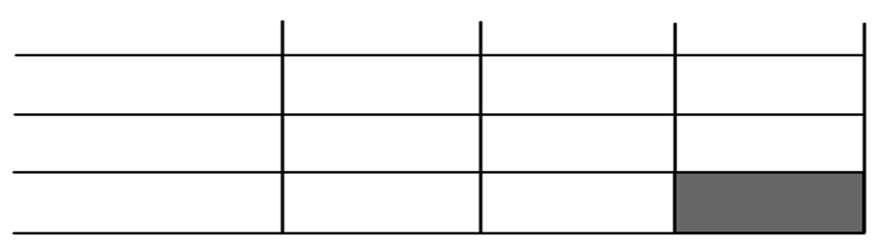Use the table on the left to organize the information (this is optional):
2. Constraints:

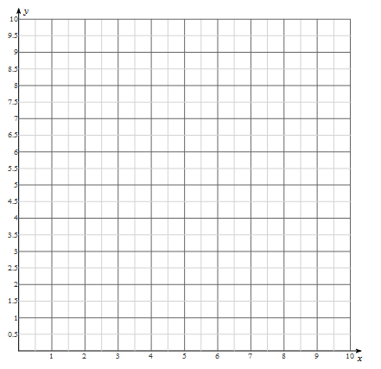

Number of Cups Puppy Power

1. Graph the constraints to answer the following questions.
2. Objective:
3. Vertices
4. Minimum Cost

Number of Cups of Doggie Dinner

**WORK SPACE**

1. # of cups Doggie Dinner

(x,y) Objective Function Value

1. # of cups Puppy Power

**2.** A bakery is making muffins and cupcakes, but they can make no more than 100 total items. In order to keep their regulars happy, they make at least 10 muffins and at least 20 cupcakes. Let ***x*** represent the number of muffins and ***y*** represents the number of cupcakes. Find the number of muffins and cupcakes that should be made to maximize profit, assuming that the profit is $2 per muffin and $3 per cupcake?

***GRAPHING*** CALCULATOR ***GRAPHING*** CALCULATOR ***GRAPHING*** CALCULATOR

1. Use the table on the left to organize the information (this is optional)****:
2. 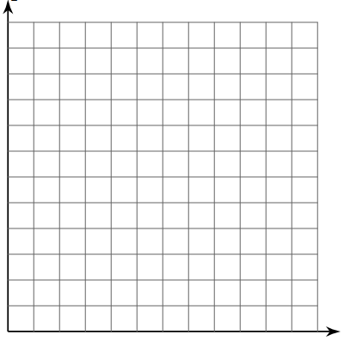Constraints:

Number of Cupcakes

1. Graph the constraints to answer the following questions.
2. Objective:

Number of Muffins

**WORK SPACE**

1. Vertices

Number of Muffins

**WORK SPACE**

1. Maximum Profit

(x,y) Objective Function Value

1. # of Muffins
2. # of Cupcakes